RAS Application Suite: Phase 3 Summary Brian Chiasson
This document provides a summary of the development activities for Phase 3 of the RAS development process. The document also outlines any changes to the previous project documentation as well as any new challenges that have arisen.

Milestones
The goal for Phase 3, as outlined by the Project Plan document, is to complete the membership features of the application and enable the food recall search. Unfortunately development has been hindered by an extreme lack of developer resources. As a result, the feature delivery for Phase 3 is significantly reduced. The plan outlined the following tasks for completion:
- Complete script to process the member registrations.
- Complete script to process the member activations.
- Configure an SMTP server for sending emails for registration (and in the future, notifications).
- Complete the script for member login.
- Ensure that the recall search can return food recall data.

Item 1 Status – Member registration script
The membership registration form was completed in Phase 2 but was not functional. The script that handles the registration of members needed to be completed. This included setting up the database to persist member data, creating the script to process the form input, and creating a class for interfacing with the email server. The following items have been completed for this task:
- The script for registering members is complete, but has not been wired up to the form. This will be completed first thing in Phase 4 (see Figure 1-1 for test output).
- Set up the user account table and complete the database setup. This is complete (see Figure 1-2).
- Creating a class for interfacing with the email server. This is complete, but the email server is not ready to deliver emails.
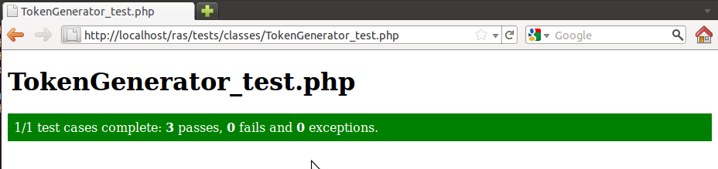

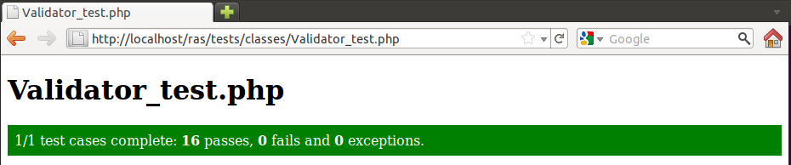
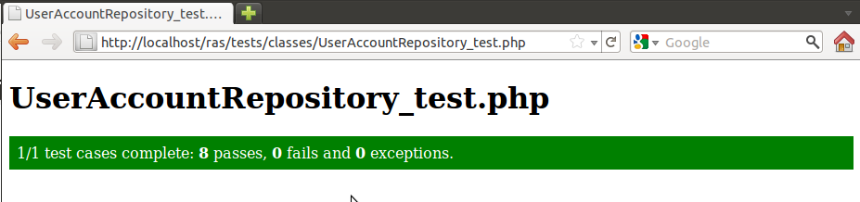
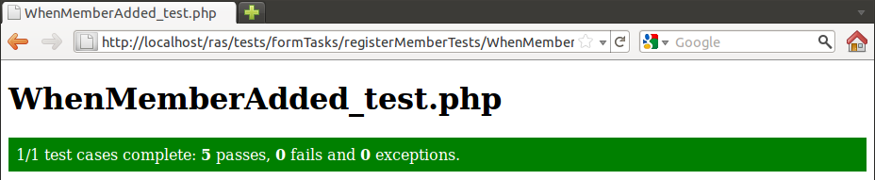
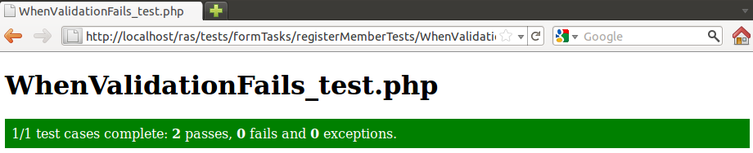
Figure 1-1: Screens of all tests that support the Member Registration script

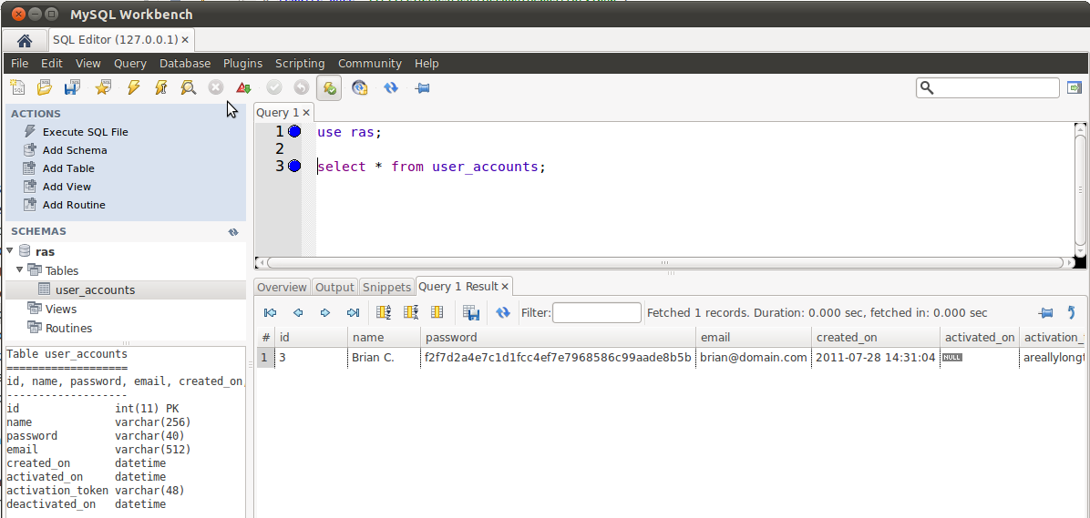
Figure 1-2: Screen of user_accounts table with record inserted from test

Item 2 Status – Complete script to process member activation
The task here was to create the controller script for processing the membership activation form input. This task is being moved to Phase 4 as developer participation in Phase 3 stressed the team's resources. (See Devlierables chart in the Document Changes section)

Item 3 Status – Configure SMTP server
This task turned out to be a huge time sink and is plaguing the development team at the moment. The SMTP server has been installed but is not relaying email. Per the recommended research, the team is attempting to use the open source email system SendMail, but configuration turns out to be a challenging task. The team hopes to complete this step in Phase 4.

Item 4 Status – Complete member login script
The task here was to create the controller script for processing the membership logins. This task is being moved to Phase 4 as developer participation in Phase 3 stressed the team's resources. (See Devlierables chart in the Document Changes section)

Item 5 Status – Add ability to search for food recall data
The task here was to enable food recall searching capabilities on the recall form. This task is being moved to Phase 4 as developer participation in Phase 3 stressed the team's resources. (See Devlierables chart in the Document Changes section)

Document Changes/Schedule Changes
We have adjusted the Project Plan's deliverables to reflect the move of the membership scripting to Phase 4. The updated chart is displayed below. It should be noted that pushing the scripting to Phase 4 has impacted Phase 5 and makes it official that the development team will not be able to get to the notifications system.

Deliverable | Date
Project Plan | 6/19
Meeting Notes | 6/20
System & Software Specification | 6/26
Meeting Notes | 6/27
Test Plan & User Guide | 7/3
Meeting Notes | 7/4
Design | 7/10
Meeting Notes | 7/11
Hosted Website (Phase 1)  Provide a hosted webpage with the ability to search for automotive recall data. | 7/17
Meeting Notes | 7/18
Membership Feature (Phase 2)  Complete website template. Enhance the website by adding a membership feature. | 7/24
Meeting Notes | 7/25
Food Recalls (Phase 3)  Complete membership control scripting. Configure SMTP server. Enhance the website by adding the ability to search for food recall data. | 7/31
Meeting Notes | 8/1
Consumer Goods Recalls (Phase 4)  - Finish member registration  - Complete SMTP server setup  - Complete membership activation  - Complete membership login  - Complete the recall search form  - Enhance the website by adding the ability to search for consumer goods recall data. | 8/7
Meeting Notes | 8/8
Touch-ups (Phase 5)  Include any bug fixes, touch-ups, and any other enhancements agreed upon. | 8/14
Meeting Notes | 8/15
Final Report | 8/21
Table 1-1: Updated Project Deliverables

Retrospective
The open source community is ripe with tools and products to assist in making development of products simpler so that developers can focus their efforts on the product and less so on the plumbing. The open source model falls down when products are selected that are difficult to configure with little to no documentation. This isn't a problem if the team isn't constrained by time as the open source community is full of participants that are willing to assist. However, because we are in a time crunch, the development team has to come up to speed quickly on a product, which doesn't always work out. This is why the SMTP server was so much trouble for the team.

